**Mockito Hands-On Exercises**

**Exercise 1: Mocking and Stubbing**

**Scenario:** You need to test a service that depends on an external API. Use Mockito to mock the external API and stub its methods.

**CODE:**

/usr/bin/env jbang "$0" "$@" ; exit $?

//DEPS org.mockito:mockito-core:3.12.4

//DEPS org.junit.jupiter:junit-jupiter-api:5.7.0

import static org.mockito.Mockito.*;

import static org.junit.jupiter.api.Assertions.*;

public class Main {

// Mocked interface

interface ExternalApi {

String getData();

}

// Class using ExternalApi

static class MyService {

private ExternalApi api;

public MyService(ExternalApi api) {

this.api = api;

}

public String fetchData() {

return api.getData();

}

}

// Manual test runner

public static void main(String[] args) {

testExternalApi();

testVerifyInteraction();

System.out.println(" All tests passed.");

}

public static void testExternalApi() {

ExternalApi mockApi = mock(ExternalApi.class);

when(mockApi.getData()).thenReturn("Mock Data");

MyService service = new MyService(mockApi);

String result = service.fetchData();

assertEquals("Mock Data", result);

System.out.println("✔ testExternalApi passed");

}

publicstatic void testVerifyInteraction() {

ExternalApi mockApi = mock(ExternalApi.class);

MyService service = new MyService(mockApi);

service.fetchData();

verify(mockApi).getData();

System.out.println("✔ testVerifyInteraction passed");

}

}

**OUTPUT:**

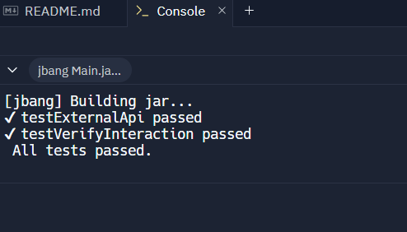

**Exercise 2: Verifying Interactions**

**Scenario:** You need to ensure that a method is called with specific arguments**.**

**CODE:**

///usr/bin/env jbang "$0" "$@" ; exit $?

//DEPS org.mockito:mockito-core:3.12.4

//DEPS org.junit.jupiter:junit-jupiter-api:5.7.0

import static org.mockito.Mockito.*;

import static org.junit.jupiter.api.Assertions.*;

public class Main {

interface ExternalApi {

String getData();

}

static class MyService {

private ExternalApi api;

public MyService(ExternalApi api) {

this.api = api;

}

public String fetchData() {

return api.getData();

}

}

public static void main(String[] args) {

testVerifyInteraction();

System.out.println(" Method interaction verified successfully.");

}

public static void testVerifyInteraction() {

ExternalApi mockApi = mock(ExternalApi.class); // Step 1

MyService service = new MyService(mockApi); // Step 2

service.fetchData(); // Step 2

verify(mockApi).getData(); //Step3

}

}

**OUTPUT:**

